**Amiga 2 Mac Floppy, reversed engineered A-Max interface**

**Module Description**

# General Description

The original A-Max II software allowed to emulate a Macintosh computer on the Amiga and provided an interface to connect an external Apple floppy drive (Figure 1) and use it in emulation. It is also compatible with CrossMAC on the Amiga so you can read Mac floppies on the Amiga.

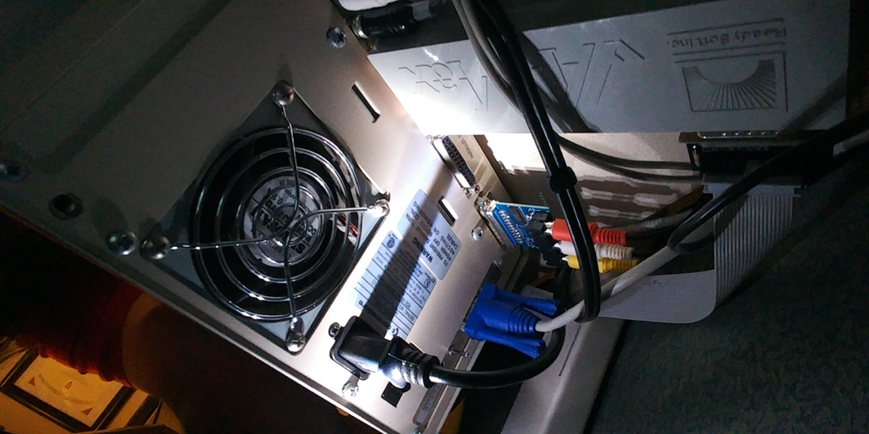

Figure -Amax II Interface

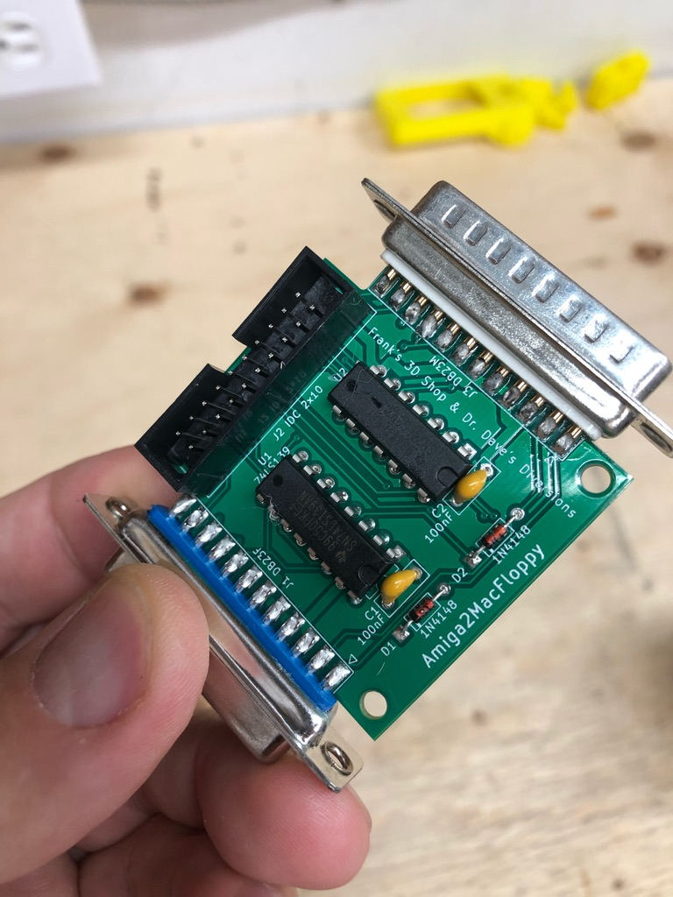

Figure 2: The Amiga2MacFloppy Interface

## Software Configuration

Using A-Max

Here are some instructions for using the interface…

# Dimensions

The dimensions of the Amiga2MacFloppy board.



Figure 3: Dimensions of the Amiga2MacFloppy Board

The PCB fits the 3D printed case .

# Revision History

## Rev. 0

* Prototype: Fully functional.

## Rev. 1

* Board cleaned up
* OpenHardware Logo added
* Remove the not needed resistor
* Added DB19 and DB23 reference files for KiCAD